**UNIVERSITI MALAYSIA TERENGGANU**

**CSM3103 FRONT-END PROGRAMMING (K1)**

**BACHELOR OF COMPUTER SCIENCE (MOBILE COMPUTING) WITH**

**HONORS**

**LAB 3**

# SEMESTER II 2023/2024

**Prepared for:**

DR. RABIEI B MAMAT

**Prepared by:**

MUHAMMAD ZAHIER BIN RAZMI

(S67943)

**Task 1**

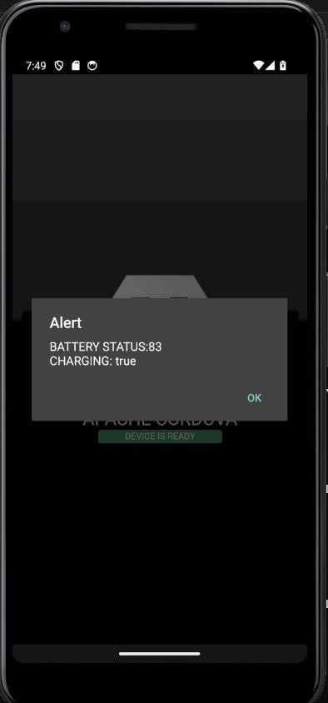

**Task 2**

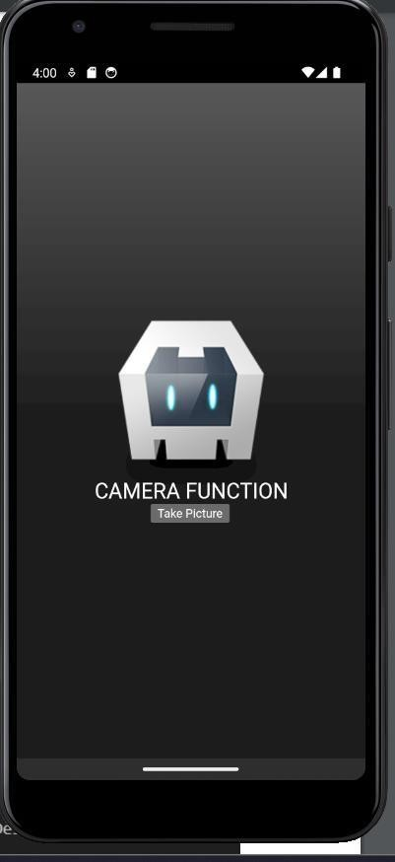

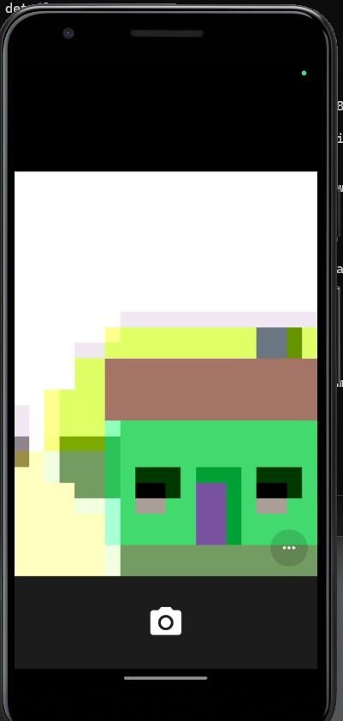

**Task 3**

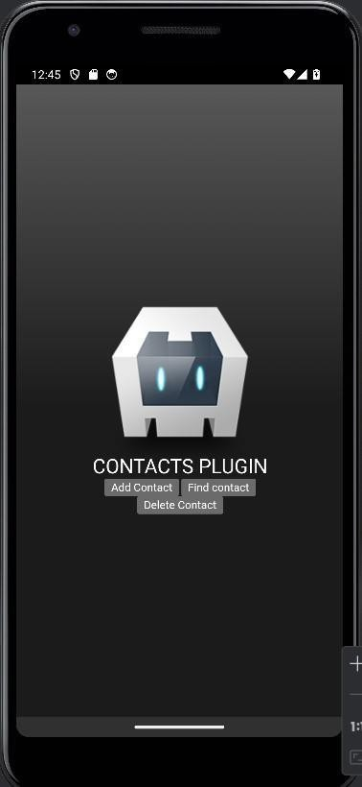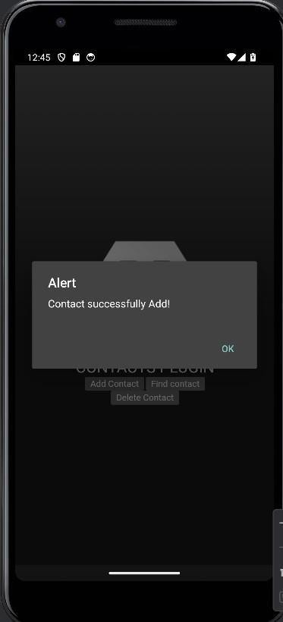

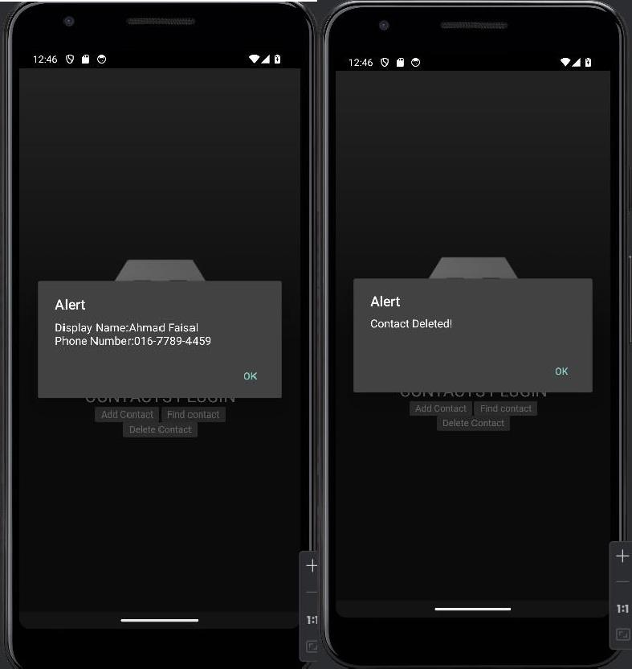

**Task 4**

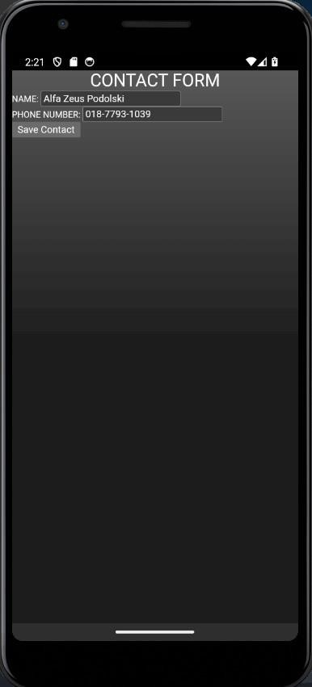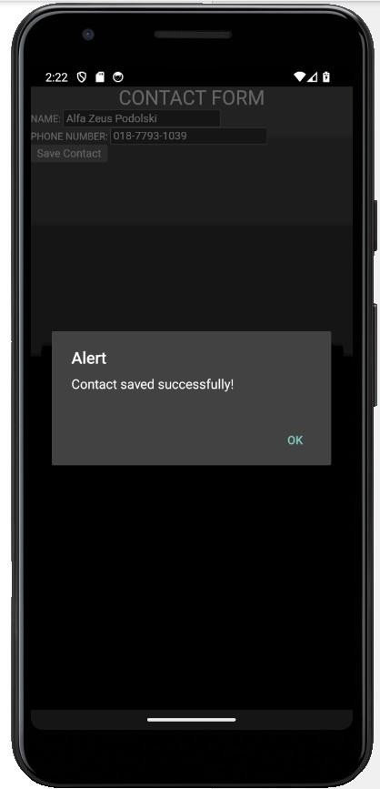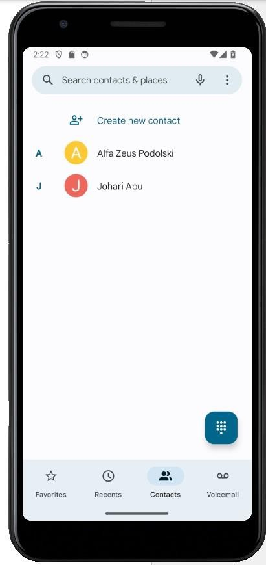

**Task 5**

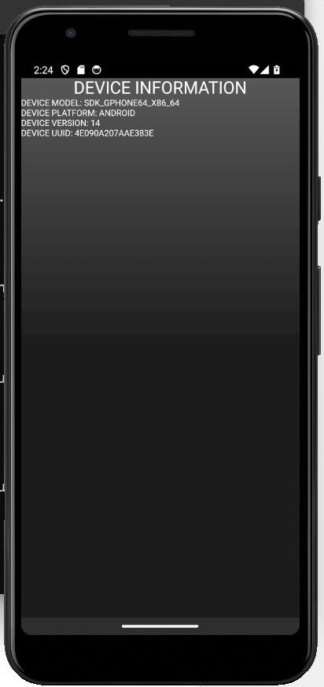

Github Repository  
https://github.com/Zahier98/S67943_CSM3103_Lab3